**Deploy an Angular application on Kubernetes**

**1 step: install angular app**

Install the Angular CLI globally by running the following command

sudo apt-get update

sudo apt-get install nodejs npm

npm install -g @angular/cli

**when this command is not run correctly**

npm install -g @angular/cli

**you will need to install nodejs 14**

1: curl -o- https://raw.githubusercontent.com/nvm-sh/nvm/v0.39.1/install.sh

2: curl -o- https://raw.githubusercontent.com/nvm-sh/nvm/v0.39.1/install.sh | bash

3: source ~/.bashrc

4: nvm list-remote

5: nvm install v16.14.0

6: nvm list

7: nvm install lts/fermium

8: node -v

successfully install nodejs 14

**Create a new Angular app by running the following command:**

**ng new my-app**

**cd my-app**

**ng serve**

app should now be accessible at <http://localhost:4200>.

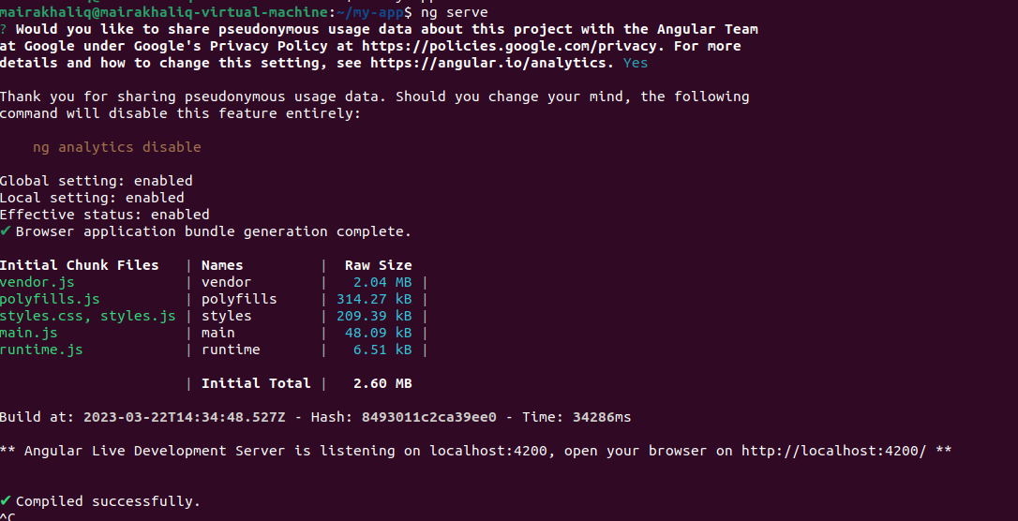

**2 step:** **Create Dockerfile**

# base image

FROM node:14.16.0-alpine3.13

# set working directory

WORKDIR /app

# install and cache app dependencies

COPY package.json /app/package.json

RUN npm install

# add app

COPY . /app

# start app

CMD ["npm", "start"]

**Build and push the Docker image: Use the command**

docker build -t my-angularapp .

**Publish the Docker image to Docker Hub**

1: docker login

2**: tag image** (sudo docker tag my-angularapp mairakhaliq/angularapp :latest)

3: docker push mairakhaliq/angularapp

image successfully push

**3 step: Create a Deployment , Pod and Service**

apiVersion: v1

kind: Pod

metadata:

name: webapp

spec:

containers:

- name: webapp

image: mairakhaliq/angularapp:latest

imagePullPolicy: Always

resources: {}

ports:

- containerPort: 8080

kubectl create -f pod.yml

**Deployment**

apiVersion: apps/v1

kind: Deployment

metadata:

name: angular-webapp

spec:

replicas: 1

selector:

matchLabels:

app: angular-webapp

template:

metadata:

labels:

app: angular-webapp

spec:

containers:

- name: angular-webapp

image: mairakhaliq/angular:latest

ports:

- containerPort: 8080

kubectl create -f deployment.yml

apiVersion: v1

kind: Service

metadata:

name: angular-webapp

spec:

type: NodePort

selector:

app: angular-webapp

ports:

- name: http

port: 8080

targetPort: 8080

1: kubectl create -f service.yml 2: kubectl get svc

3: kubectl get pods 4: kubectl get deployment

**Deploy an Vue.js application on Kubernetes**

**Step 1: Install node.js**

sudo apt install nodejs

nodejs –version

**Install npm**

sudo apt install npm

npm –version

npm install vue@next

**Installing Vue.js by Using CLI**

sudo npm install -g @vue/cli

vue –version

sudo npm update -g @vue/cli

**Create a Vue.js Application using CLI**

vue create my-app

cd my-app

npm run serve

**Step 2: Create Dockerfile**

# base image

FROM node:lts-alpine

# set working directory

WORKDIR /app

# copy package.json and package-lock.json

COPY package*.json ./

# install dependencies

RUN npm install

# copy project files and folders to the container

COPY . .

# build for production with minification

RUN npm run build

# expose the port the app runs on

EXPOSE 8080

# start the app

CMD [ "npm", "run", "serve" ]

**Build and push the Docker image: Use the command**

docker build -t my-vue-app .

**Publish Docker image to Docker Hub**

1: docker login

2**: tag image** (docker tag my-vue-app:latest mairakhaliq/my-vue-app:latest)

3: docker push mairakhaliq/my-vue-app

image successfully push

**3 step: Create Pod and Service**

apiVersion: v1

kind: Pod

metadata:

name: my-vue--app

spec:

containers:

- name: my-vue-app

image: mairakhaliq/my-vue-app:latest

imagePullPolicy: Always

ports:

- containerPort: 8000

---

apiVersion: v1

kind: Service

metadata:

name: my-vue-app

spec:

type: NodePort

selector:

app: my-vue-app

ports:

- name: http

port: 8000

targetPort: 8080

kubectl apply -f pod.yml

**Verify that the Pod and Service are running by running the following commands:**

kubectl get pods

kubectl get services